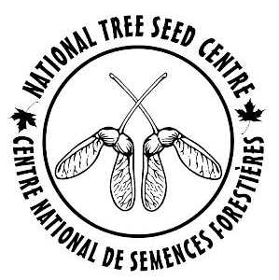
National Tree Seed Centre
Seed Request Form
The National Tree Seed Centre (NTSC) provides small quantities of seed at no cost for scientific research purposes only. To request seed, fill out the form and return it to the Seed Centre.
Applicant Information
Name:
Organization:
Position:
Telephone:
Fax:
Email:
Seed will be sent by regular mail at no charge or by courier at the client’s expense.
Shipping or mailing address:
Courier and account number:
Seed Request Information
If necessary, please attach a separate page providing the information below.
Species |  | NTSC Number* | Number or weight of seed
* The seedlots and their NTSC numbers are available in the CAFGRIS database.
An Import Permit may be required for seed requests from outside Canada. When the Import Permit is received, the Seed Centre will obtain a Phytosanitary Certificate which will accompany the shipment.
Seed Use Information
The Seed Centre is interested to know how you intend to use the seeds. If field trials are established, we would be interested in receiving summaries of future assessments. Thank you for providing us with this information.
Use of seed:

Project description:
If this is your first time requesting seed from the National Tree Seed Centre, how did you learn about us?

Please send your completed form by email, fax or post to:

National Tree Seed Centre
Natural Resources Canada
Canadian Forest Service–Atlantic Forestry Centre
PO Box 4000, Fredericton, New Brunswick, E3B 5P7 CANADA
Tel: 506.452.3289 Fax: 506.452.3289 Email: donnie.mcphee@canada.ca

